AVI 4M: Drawing Unit Project

For the drawing unit, you will create 1-2 major art works from the list below. You may use any material you like however, they must be different for each drawing. You may experiment with charcoal, conte, pencil crayons, chalk pastels, oil pastels, etc. Remember the elements and principles of design as well as composition!

Before you begin your art work, you must first follow the creative process in your sketchbook by:
- Generating and brainstorming ideas – research images, come up with an idea
- Planning – exhaust all ideas before settling, gather necessary supplies
- Exploring and experimenting – create rough sketches, practice techniques
- Revising and refining – discuss with peers and teacher if necessary, edit rough work
Your theme and sketches must be approved before you begin.

Choose 1-2 of the following:

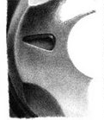
- Close up of an object of your choice: This may be a found object, something you use every day, something abandoned, broken, precious, sentimental, old, etc. Consider foreshortening.
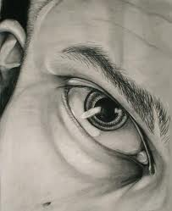
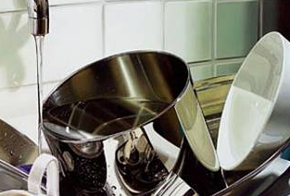

- Weave drawing: Choose 2 pictures (photographs, magazine, etc.) that have a common theme or idea. Find one that is predominately darker and the other lighter. Cut the first picture into vertical strips. Cut the second picture horizontally into strips. Weave the strips together to create an interesting composition and tape down. (weave does not need to be perfect as you can see below) On a larger sheet of paper, create an enlarged grid. There should be the same number of squares as in the design. Transfer the design draw each square.
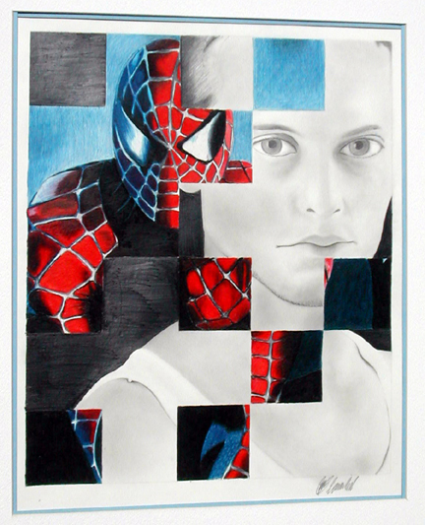
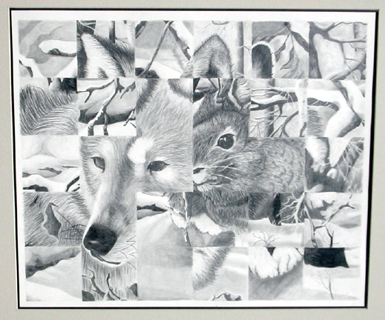
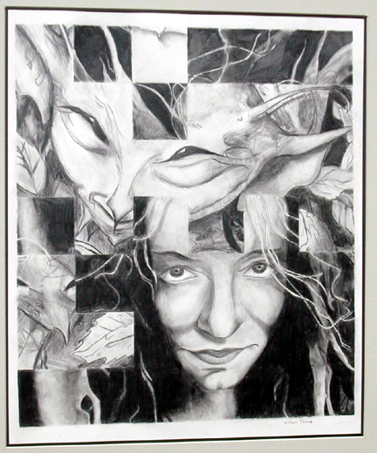
- Hand-scape: You will draw realistic-looking hands in a fantasy landscape. You may choose any gesture for your hand(s). You may want to research these artists: Salvador Dali, Rene Magritte.
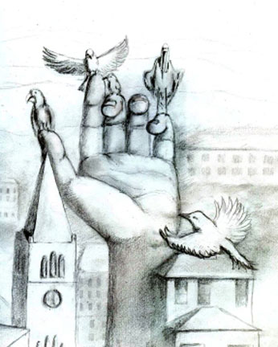
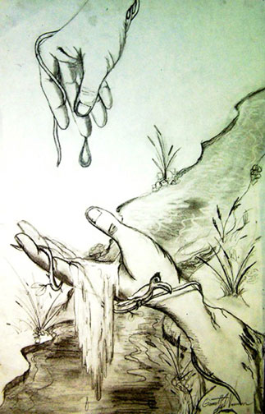
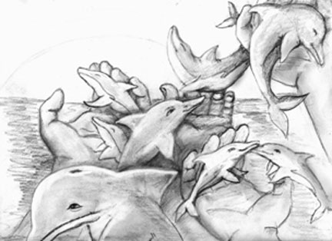

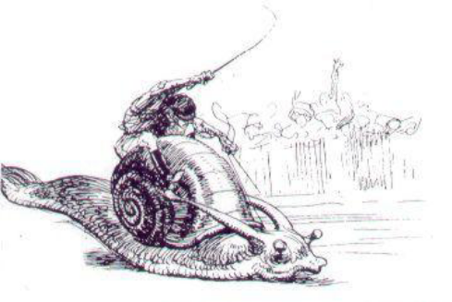
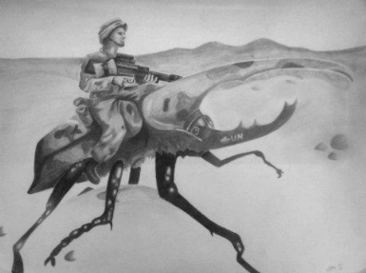
- Dynamic mode of transportation: Select one insect from the list below and begin thinking of ways of incorporating it into a dynamic mode of transportation. Research your insect and find a few pictures you would like to work with. Your drawing must include a human with the insect.
Spider
Millipede
Moth
Dragonfly
Cockroaches
Termites
Ladybug
Walking Stick
Honey Bee
Fly
Grasshopper

Beetle
Butterfly
Snail
Ant
Wasps
Centipede
Mayflies
Scorpions
Mosquito
Praying Mantis

- Realistic technical study: Select your subject matter and recreate it as realistically as possible paying close attention to technique, detail, and precision.
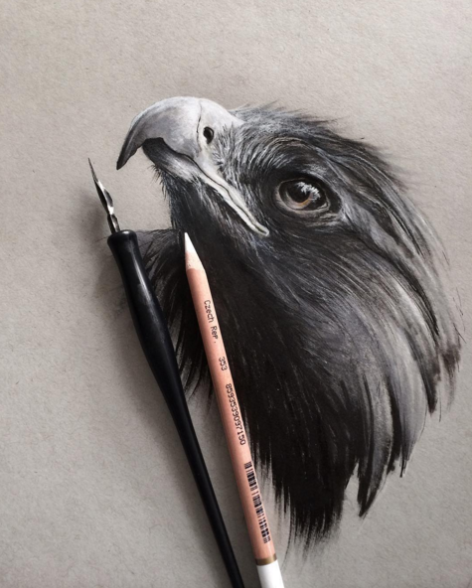
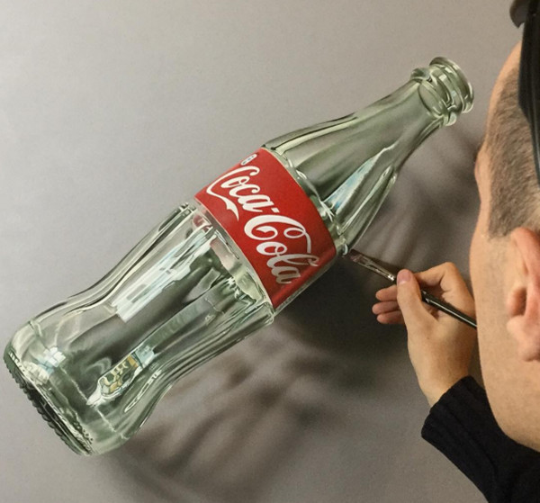
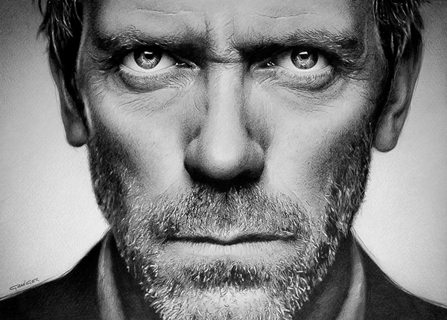

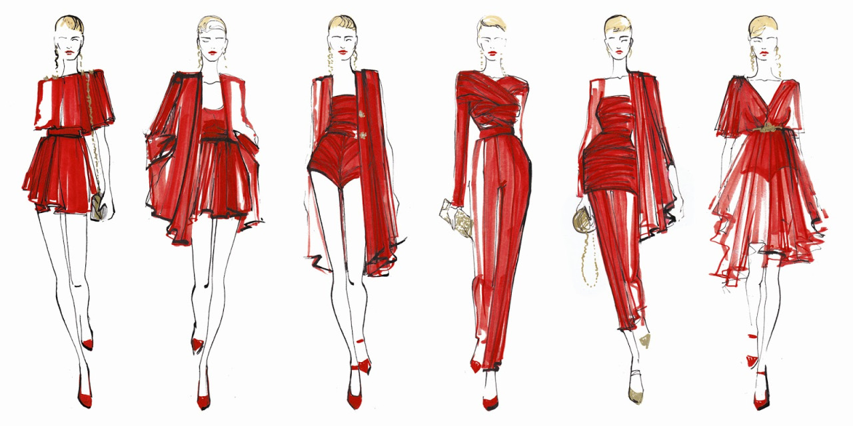
- Fashion Design: You have been hired by a design company to create a series of 3 original fashion designs

Drawing Unit Rubric Name: __________________________
 | Criteria | Mark
FOUNDATIONS  Studio work | - You came to class prepared  - You put forth a consistent effort  - You met the deadline  - You used class time well  - You asked for advice when needed  - You used studio supplies with care  - You cleaned up after using supplies  - You followed instructions and the creative process | /20
CREATING  Technique/Design/Composition/  Elements and Principles/Quality | - You showed an understanding of good technique  - Your composition is interesting and successful  - You showed an awareness for elements and principles of design  - The quality of your work is impeccable  - Your art is unique and creative and not simply a copy of artwork found online  - You used appropriate materials for your idea  - You have met all the criteria | /20
REFLECTING  Written/Oral Critique | - To be discussed | /10

