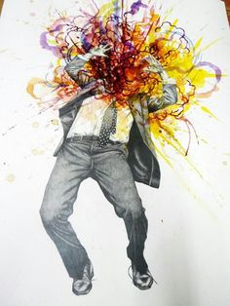
Free Choice Unit

For this unit, you will create 1 major artwork using a medium of your choice. Choose from one of the unused topics from this semester or explore other ideas. Your idea and sketch must be approved before you begin.

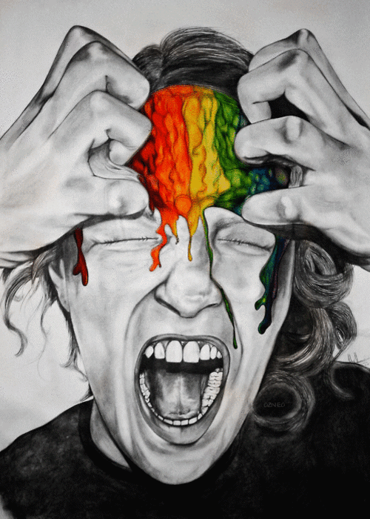
Before you begin your art work, you must first follow the creative process in your sketchbook by:
- Generating and brainstorming ideas – research images, come up with an idea
- Planning – exhaust all ideas before settling, gather necessary supplies
- Exploring and experimenting – create rough sketches
- Revising and refining – discuss with peers and teacher if necessary, edit rough work

Free Choice Unit Rubric Name: _______________________
 | Criteria | Mark
FOUNDATIONS  Prep-work & Studio work | - You came to class prepared  - You tried your very best  - You met deadlines  - You followed instructions  - You used class time well and didn’t waste time getting started  - You found appropriate images/theme to work from  - You asked for advice when needed  - You used materials properly and helped clean up | /10
CREATION  Design/Composition/ Elements and Principles/ Quality/Craftsmanship | - Your idea and accurately and effectively conveyed  - You showed an awareness for elements and principles of design  - Your composition is interesting and successful  - You used appropriate materials for your idea  - Your work is neat, well executed and you have put forth an excellent effort  - Your work is creative and unique  - You have put a great deal of thought into this | /20
COMMUNICATION  Oral Critique | - We will have an informal critique about each artwork where you will be expected to explain your idea, process and design choices | /10
TOTAL: /40

