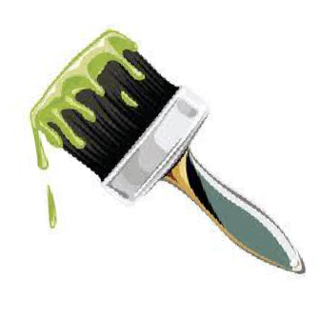
AVI 4M: Painting Unit Project
For the painting unit, you will create 1-2 major art works from the list below.
You will use acrylics or watercolours. Remember the elements and principles of design as well as composition!

Before you begin your art work, you must first follow the creative process in your sketchbook by:
- Generating and brainstorming ideas – research images, come up with an idea
- Planning – exhaust all ideas before settling, gather necessary supplies
- Exploring and experimenting – create rough sketches, practice techniques
- Revising and refining – discuss with peers and teacher if necessary, edit rough work

Choose 1-2 of the following:

- Social consciousness: must make a visual statement (no text may be used) about a social justice, social consciousness or environmental issue. Ie. Racial inequality, gender inequality, environmental issues, societal inequality, political inequality, etc…
- Figure study: must somehow incorporate the human body.
- Historical art style: must be in the style of one of the art history periods studied this semester.
- Choose from one of the unused drawing unit topics.

Your idea and sketches must be approved before you begin.

Painting Unit Rubric Name:

 | Criteria | Mark
FOUNDATIONS  Studio work | - You came to class prepared  - You put forth a consistent effort  - You met the deadline  - You used class time well  - You asked for advice when needed  - You used studio supplies with care  - You cleaned up after using supplies  - You followed instructions and the creative process | /20
CREATING  Technique/Design/ Composition/  Elements and Principles/Quality | - Your image is accurately drawn out  - You showed an understanding of good technique (building colours and working in layers)  - Your composition is interesting and successful  - You showed an awareness for elements and principles of design  - The quality of your work is impeccable  - Your art is unique and creative and not simply a copy of artwork found online  - You used appropriate materials for your idea  - You have met all the criteria | /20
REFLECTING  Written/Oral Critique | - To be discussed | /10

